1. Check and remove the old DPR forwarding

The old DPR divert called "CPR Direct" as a service

Stop the service in the service panel.

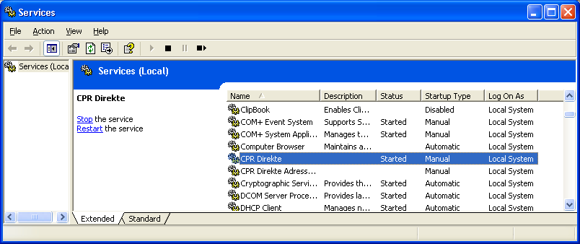

Verify that the old diversion works with respect to connection and login to CPR, start the program up and activate the test button!

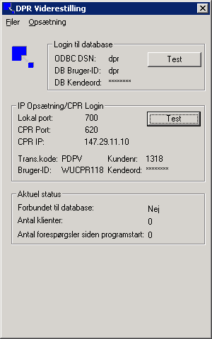
Figure1The OLD DPR Diversion tested

You start the program DprDirSrv.exe
And press the lower the test button.

The last two figures in the answer should be 00 - otherwise there is something wrong.

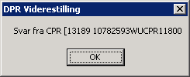

Setting up the old DPR forwarding lies in the registry (and unfortunately) at the same location as the setup for a possible DPR client.

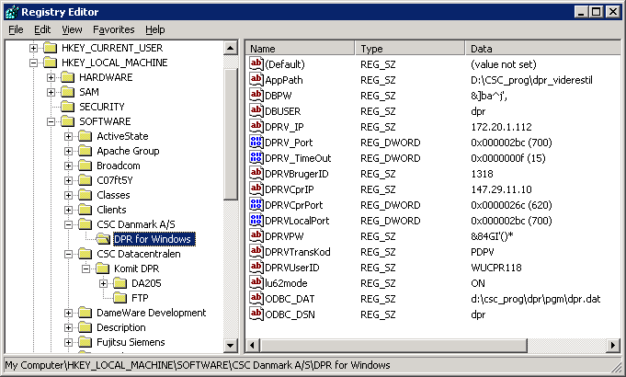

Make an export of this location in registry.

Key DPRVPW contains an encrypted version of password CPR. Reuse of this CPR Direct registry if you do not know password'et.

Write-install the old DPR forwarding, which unfortunately says "CPR direct":

Man makes himself at a command prompt in the directory where the old DPR forwarding installed and write the following incantation:

SVCCPR.EXE UnInstall

Following the refresh of the service panel is service'en "CPR Direct" away.

2. Installing CPR + Direct Service Program

Run setup.exe and follow the instructions.

Run the setup of the service program.

Trans code for CPR Direct isPDPR

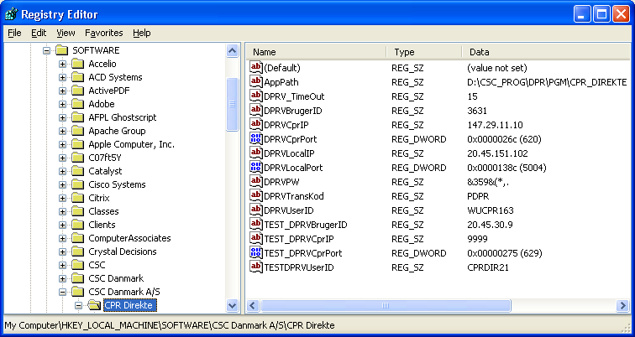

Run CPR Directed by ordinary program and organization setup by selecting the menu item "Setup"

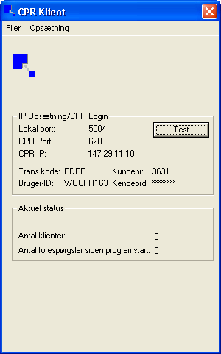

There is a small test client, where you can test whether CPR Direct works.

It's a good idea to test this - CPR Directly runs both as a program and as a service

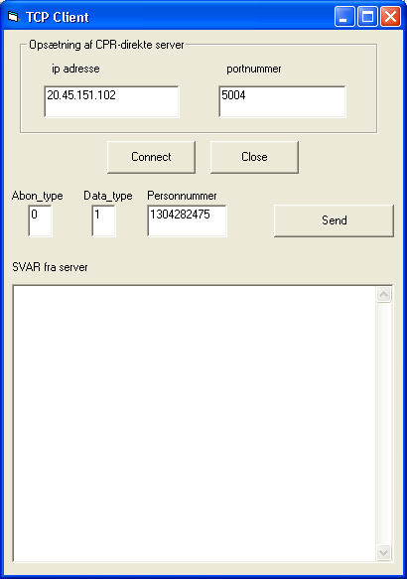

Select the data type 6 and a known person.

To install CPR direct as service:

- Close possibly ride version of CPR Direct.
- Open the registry and create the following key and data under [HKEY_LOCAL_MACHINE \ SOFTWARE \ CSC Danmark A / S \ CPR Direct]
String Value: AppPath Value: Path to CPRDirSrv.exe example C: \ Program Files \ CPR Direct. Run the supplied service program SVCCPR.EXE with parameter INSTALL to install Direct CPR as NT Service.
- Start the Service Manager in the Control Panel and enter the startup parameters of CPR Service Direct.
- Start the service.

3. Installation of the new DPR forwarding.

Run the installation of the DPR passed II.

To use an administrator user. If you enter the wrong password fails setup (run just one more time).

Remember copying DPRvidere EXE as described.

Divert service to auto-start and switch to local system account.

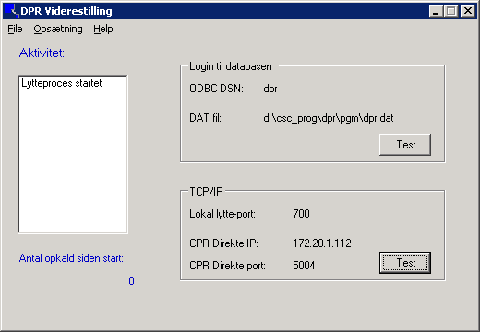

Start DPRvidere.exe and organization setup.
Diversion will no longer point to the central CPR, but instead on the local server
running CPR Direct (Typical itself) with the selected port. (here 5004).

